Homework 2 – 2.9 Exercises

3. 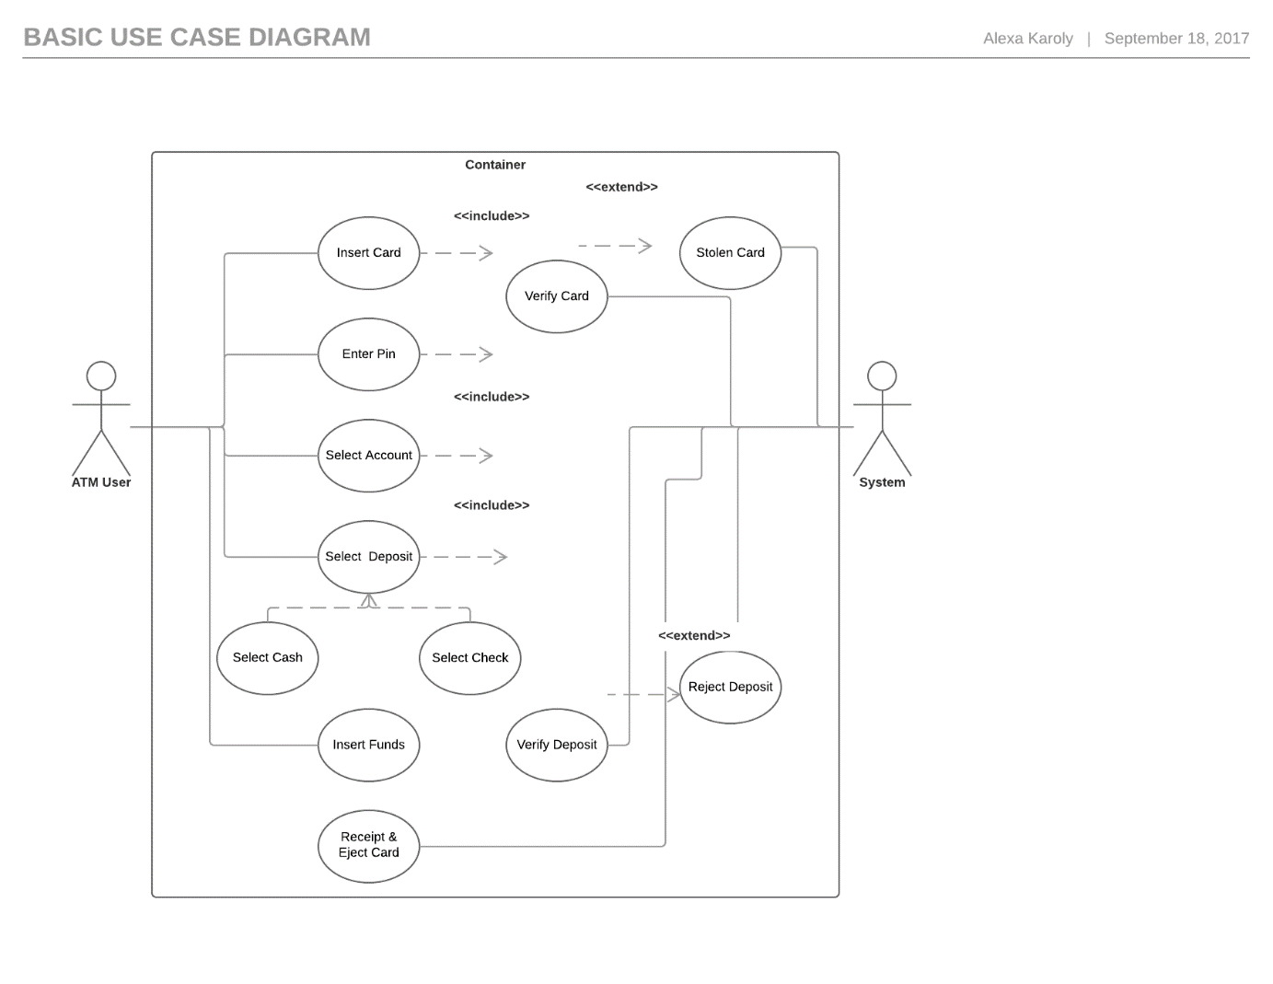

|  |  |  |  |
| --- | --- | --- | --- |
|  | **Action Performed By the Actor** |  | **Responses From the System** |
| 1. | Inserts debit card into the ‘Insert Card’ slot |  |  |
|  |  | 2. | Asks for the PIN number. If PIN or card is invalid, go to step 8. |
| 3. | Enters the PIN |  |  |
|  |  | 4. | Verifies the PIN. Asks for deposit type. |
| 5. | Enters deposit type (cash or check) |  |  |
|  |  | 6. | Verifies type selected. Waits for entry. |
| 7. | Inserts funds |  |  |
|  |  | 8. | Verifies amount deposited. If check is illegible or deposit is rejected, go to step 8. |
| 9. | Requests receipt. Finishes transaction. |  |  |
|  |  | 10. | Ejects card |
| 11. | User takes the card |  |  |

4. 